[Luz] Flash Yongnuo Speedlite YN460
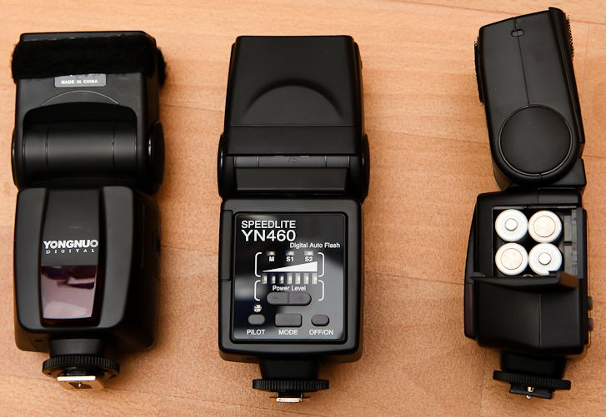
Features Specifications
- NG: 33
- Circuit design: IGBT
- Up/down ward angle: 0-90 degree
- Left/right angle: 0-270 degree
- Power Source: 4 X AA size batteries (Alkaline or Ni-MH are usable)
- Battery Life: 100 - 1500 times (with alkaline batteries)
- Recycle Time: 5 sec(with alkaline batteries)
- Color Temperature: 5600K
- Flash Duration: 1/800S - 1/20000S
- Flash adjustment: “7 difference flash power level ( 1/1, 1/2, 1/4, 1/8, 1/16, 1/32, 1/64 )”
- Power Saving: “ Stand by mode, 30mins to power off mode. 60mins to power off when using the optic mode. ”
- Dimensions: 72X135X85mm
- Weight: 250g
- Slave mode S1: Normal optical slave
- Slave mode S2: Pre-flash cancel slave

